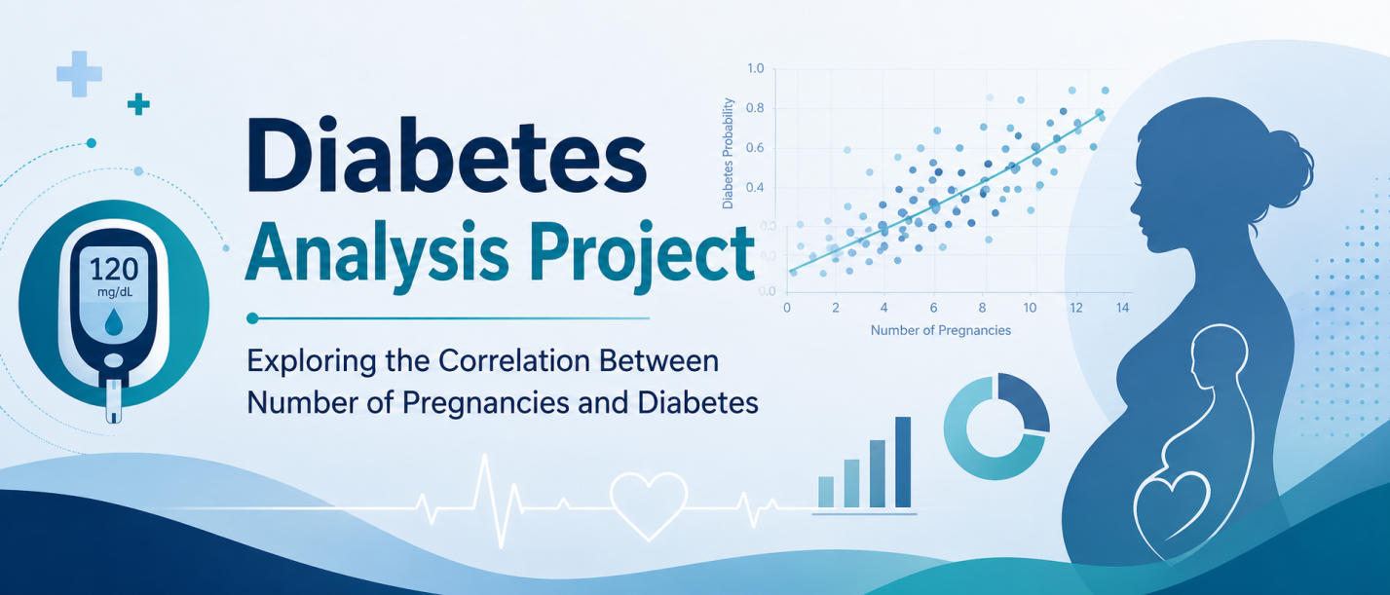

Hypothesis
This project studies whether the number of pregnancies is related to diabetes in Pakistani women.
The hypothesis is:
Women who have had more pregnancies may have a higher chance of having diabetes.
In simple words, the project checks if diabetes becomes more common as the number of pregnancies increases.

Methodology
The data was imported into Jupyter Notebook using Python. The dataset was stored in a CSV file and loaded using the pandas library.
After loading the data, the columns were checked to understand the information in the dataset. The project focused mainly on the columns related to:
- Number of pregnancies
- Diabetes outcome
Graphs were created to see the distribution of the data. A histogram was used to show how the values were spread across the dataset.
The relationship between pregnancies and diabetes was then studied by comparing the number of pregnancies with the diabetes result. This helped to see whether women with more pregnancies had a higher rate of diabetes.

Results
The analysis showed that the number of pregnancies may have some relationship with diabetes among Pakistani women.
The graphs helped show the pattern of the data and made it easier to understand how pregnancies were distributed in the dataset. The results suggest that women with a higher number of pregnancies may be more likely to have diabetes compared with women who had fewer pregnancies.
However, pregnancy is not the only reason for diabetes. Other factors such as age, weight, blood pressure, glucose level, family history, and lifestyle may also affect the chances of having diabetes.
Overall, the project suggests that there may be a connection between the number of pregnancies and diabetes, but more detailed analysis is needed to confirm how strong this relationship is.

